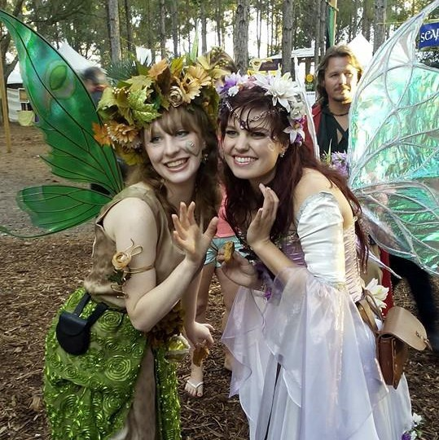Every fairy needs a place to live. Their homes, each a representation of the fairy’s personality and season, are filled with magic and pixie dust. They are made with materials from the forest and held to- gether with tree sap. Every night fairies shrink to a tiny size and return to their homes to work on their magic.
We need your help! The fairies of our shire are looking for new neighbors.
Build a fairy house for the neighborhood and
tell us about the fairy who lives there.

Felicity, the Summer Fairy, has a house filled with sunlight and the many colors of the summer field. But she always has a shady spot for a tea
party with her sister Lily,
the Spring Fairy.

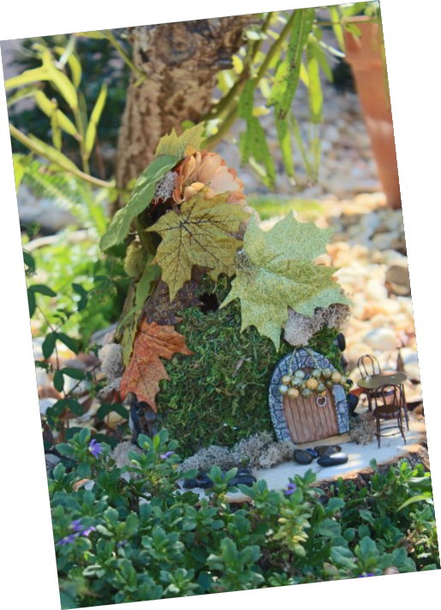
Rules
• Use natural materials – dry grasses, leaves, sticks, pebbles, shells, bark from a fallen tree, seed pods, acorns, berries, gourds, miniature pumpkins, pinecones, and flowers are a few examples.
• All fairy houses must appear to be made entirely of natural components. Hot glue, acrylic spray, twine and other man- made items can be used but must be completely concealed by natural elements. No paper product (they melt in the rain),
and no metal (it’s toxic to fairies!)
• Platforms or man-made support materials can be used for easier delivery and transport, but must be concealed with natural materials when installed on-site.
• Houses must be portable (maximum dimensions 16” by 16” and 24” high) - please use a sturdy base that can hold up if wet (such as plywood).
• Please do not use any items of value in the houses as the Faire is not responsible for any loss or damage
• The theme of the house may be anything you wish.
• Please have your name and your house’s name clearly marked and attached to the house.
• All fairy house creators must complete the submission form and turn it in with the house.
• Fairy Houses become the property of the Lady of the Lakes Renaissance Faire and will NOT be returned to the creators.
• Fairy houses must be dropped off at any branch of United Southern Bank in Lake County no later than 4:00 PM on Octo- ber 26th, 2017
• Winner will be announced on October 31st, 2017.

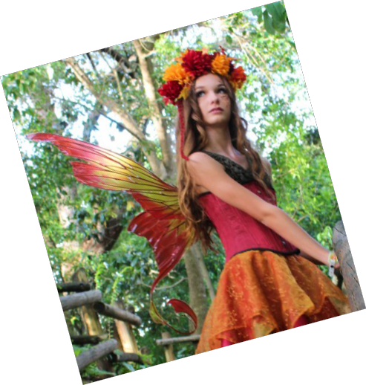Prizes
Grand prize winner will be awarded a gift basket containing four tickets to the Lady of the Lakes faire, two Lady of the Lakes ceramic mugs, four Lady of the Lakes t- shirts, and an audience with King James and Queen Anne.

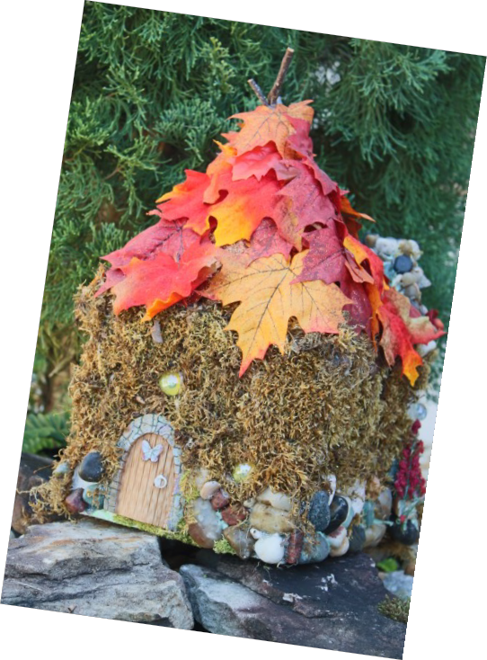Every entry will receive one free ticket for The Lady of the Lakes
Renaissance Faire!

For more information contact The Educational Foundation of Lake County:

352-326-1265
edfoundation@lake.k12.fl.us

CONTACT INFORMATION
Registration Form

Name Name of Fairy House

Address

City State Zip code

Phone # Email

Alternate Contact Name Alternate phone #

Tell us the story of your fairy:

Rules
• Use natural materials – dry grasses, leaves, sticks, pebbles, shells, bark from a fallen tree, seed pods, acorns, berries, gourds, miniature pumpkins, pinecones, and flowers are a few examples.
• All fairy houses must appear to be made entirely of natural components. Hot glue, acrylic spray, twine and other man- made items can be used but must be completely concealed by natural elements. No paper product (they melt in the rain),
and no metal (it’s toxic to fairies!)
• Platforms or man-made support materials can be used for easier delivery and transport, but must be concealed with natural materials when installed on-site.
• Houses must be portable (maximum dimensions 16” by 16” and 24” high) - please use a sturdy base that can hold up if wet (such as plywood).
• Please do not use any items of value in the houses as the Faire is not responsible for any loss or damage
• The theme of the house may be anything you wish.
• Please have your name and your house’s name clearly marked and attached to the house.
• All fairy house creators must complete the submission form and turn it in with the house.
• Fairy Houses become the property of the Lady of the Lakes Renaissance Faire and will not be returned to the creators.
• Fairy houses must be dropped off at any branch of United Southern Bank in Lake County no later than 4:00 PM on Octo- ber 26th, 2017
• Winner will be announced on October 31st, 2017.

For more information

contact The Educational Foundation of Lake County:
352-326-1265
To be used by Renaissance Faire Staff only:

FAIRY HOUSE NUMBER:

