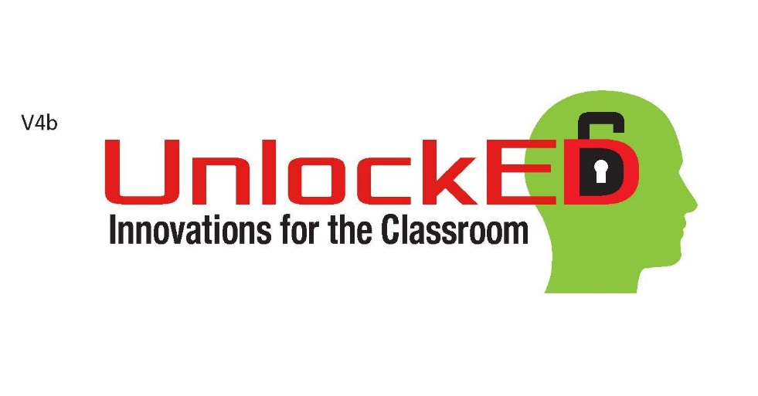
What is UnlockED?
UnlockED provides teachers the support, time and space to hone and execute big ideas in the best interest of their students and their profession. After a competitive selection process, planning with business professionals and a community pitch preparation, UnlockED competitors will present ideas for funding to make their ideas a reality in front of judges, peers and the Lake County community.

Who Can Participate and How Does One Participate?
Innovative Teacher Leaders who cultivate authentic ties to the community to
benefit their students. Teacher Leaders who are innovation ready and take
advantage of emerging technology tools. Teacher Leaders who are ready to
strengthen public education and teaching through community involvement.
The Foundation will accept concepts from teachers, teacher teams or schools.
A committee will score and select the five big ideas to proceed to the next level.
At that level each team will be partnered with an accountant, public relations
expert and a business CEO to develop and expand the idea in 2 meetings over
the summer. The Community Selection event will be held in October 2017.

When and Where?
Submission forms for concepts are now available at the foundation website www.edfoundationlake.com and are due back to the foundation by June 15, 2017. The five selected concepts will be assigned their business team and will meet once in July and once
in August to develop the idea. For more detailed information, please contact
cullen-battc@lake.k12.fl.us or 352-326-1265.

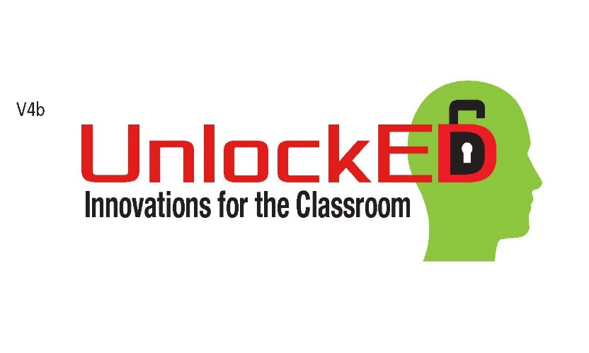

An Invitation for Innovative Grant Concepts
Five concepts will be selected to move on to the UnlockED Grant Process. The concept must address one of the foundation’s funding priorities, which include Literacy, Graduation rates, STEM, or Low-Performing Students. The scoring model will be built on the following components: Is the concept innovative? How many students will benefit from the concept? What is the goal of the concept and how will it increase student performance? Is the concept sustainable? Is the concept duplicable? Will the concept increase enthusiasm among educators AND students?
A minimum award pot of $65,000 will be available. A team consisting of an accountant, public relations executive and a CEO will be assigned to each teacher, team, or school to develop the concept and to prepare for a community presentation to determine funding in October 2017.
Lead Teacher Name __________________________________________________________
School Name _________________________________________________________________
Email Address ________________________________________________________________
_____ Literacy ______ Graduation Rates ______ STEM ______ Low-Performing
Principal Signature ___________________________________________________
DEADLINE: Wednesday, June 15, 2017 by 5 p.m.
Email or mail to Educational Foundation: Cullen-battc@lake.k12.fl.us or 2045 Pruitt Street, Leesburg, FL 34748

UnlockED Concept (500 words or less)

_____________________________________________________________________________________
_____________________________________________________________________________________
_____________________________________________________________________________________
_____________________________________________________________________________________
_____________________________________________________________________________________
_____________________________________________________________________________________
_____________________________________________________________________________________
_____________________________________________________________________________________
_____________________________________________________________________________________
_____________________________________________________________________________________
_____________________________________________________________________________________
_____________________________________________________________________________________
_____________________________________________________________________________________
_____________________________________________________________________________________
_____________________________________________________________________________________
_____________________________________________________________________________________

