Media Contact:
Carman Cullen
352-504-5327
cullen-battc@lake.k12.fl.us
For Immediate Release – May 25, 2021

East Ridge High School High Tech team wins statewide Project Venture competition
The Able Trust program helps high school students with disabilities develop communication and entrepreneurial skills.

LEESBURG – The “Condiment Launcher,” designed by East Ridge High School students in Lake County’s High School High Tech (HSHT) program, was the top pick by judges in The Able Trust’s 2nd Annual Project Venture Business Development Competition.

The East Ridge team was named champions after presenting their “Love the Launch” concept to a panel of judges made up of manufacturing, technology and higher education professionals. The team, sponsored by exceptional student education (ESE) teacher Nicole Marconi, was one of five finalists in the statewide competition.

The students’ presentation included a :30 video commercial and a PowerPoint presentation detailing the research, costs and projected revenue for the Condiment Launcher which is designed to improve efficiencies at restaurants, school cafeterias and other eatery-based locations. The East Ridge High School team’s commercial can be viewed at https://vimeo.com/531862614.
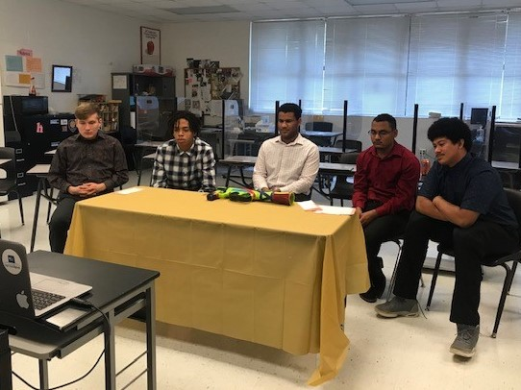
The East Ridge High School team presented their concept “Love the Launch” virtually to a panel of judges in The Able Trust’s 2021 Project Venture statewide competition.

Pictured left to right: Robert Rosser, Shalamar Levarity, Ferneli Pena, Armand Thomas, Jason Arroyo.

Not pictured: Ryan Anderson, Dakota Hernandez, Jacob Murshalin, Rishard Noel.

-more-
“I am so proud of our HSHT students for taking first place in Project Venture. The students did an exceptional job preparing and presenting their project,” said Julie Robinson-Lueallen Principal, East Ridge High School. “Ms. Marconi is a phenomenal teacher who goes above and beyond to ensure students find success. Congratulations to our HSHT Knights.”

The team’s win earned The Education Foundation of Lake County $1,500 to use toward the District’s High School High Tech program.

The Florida Department of Vocational Rehabilitation and The Able Trust partners with organizations around the state, including the Education Foundation of Lake County, to provide key services to high school students with disabilities (SWDs) and their families.

The HSHT program provides high school students with all disabilities the opportunity to explore jobs or postsecondary education leading to successful careers. The program is designed to: 1) improve participation in education, vocational and employment-related activities for youths with disabilities; 2) increase their enrollment in postsecondary education and training; and 3) help them identify and pursue a successful career path.

During the 2020-2021 school year, the HSHT program served more than 1000 students with disabilities at 43 sites in 40 counties and achieved a graduation rate of 99% for all participating seniors. The program has a 77% continuing education rate which they want to see increase every year.

“The Able Trust is excited at the level of participation and quality of projects in this year’s completion in spite of covid-related hurdles,” said Joseph D’Souza, State Director, High School High Tech. “Our High School High tech students are truly a creative and innovative group, and the Project Venture competition really lets them shine. Participating in High School High Tech is a choice for our students. They are go-getters and they take advantage of every opportunity available to them to get them college and work ready. The Able Trust couldn’t be prouder of them.”

About the Education Foundation of Lake County
Established in 1987, Education Foundation of Lake County is a 501(c)(3) nonprofit organization and designated direct support organization for Lake County Schools. Our mission is to serve as the connection between our community and public education, evaluating needs and securing resources to enhance the quality of education. The Education Foundation of Lake County operates for the benefit of students and teachers in Lake County Public Schools.

Education Foundation of Lake County is ranked among the Top 50 Education Foundations in the United States by the Caruthers Institute. For more info, please visit EdFoundationLake.com.

###

